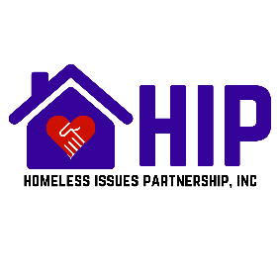
Membership Application and Invoice
July 1, 2026 – June 30, 2027
The Homeless Issues Partnership is a regional coalition of agencies, individuals, and businesses addressing and resolving issues related to homelessness in Nueces County through actions, advocacy, resources, and education.
Please check box(s) if you are interested in being a committee member or volunteering for one or more of the following HIP Committees
Lived Experience Gaps & Needs Assessment Inclement Weather Events

Point-in-Time (PIT) Social Media

By signing this membership, you acknowledge and agree to comply with the Code of Conduct associated with this coalition.
AGENCY / ORGANIZATION MEMBERSHIP - $50.00 – One Vote Per Paid Member
Name of Agency/Organization:
Address: |  |  | City: |  |  |  | State: | Zip:
Phone: | Fax: |  | Cell: |  | Email:
Voting Member Name: |  |  |  | Title:
Authorized Signature: |  |  |  |  |  | Date:
Authorization to use agency logo as partnership with HIP: Yes |  |  |  |  |  | No
Check #: |  | Cash: |  |  |  | Amount:
To Be Completed by HIP Treasurer for Organization Membership
Check #: |  | Cash: |  |  |  | Amount:
INDIVIDUAL MEMBERSHIP - $25.00 – One Vote Per Paid Member
Name of Individual:
Address: |  |  | City: |  |  |  | State: | Zip:
Phone: | Fax: |  | Cell: |  | Email:
Authorized Signature: |  |  |  |  | Date:
Check #: |  | Cash: |  |  | Amount:
To Be Completed by HIP Treasurer for Individual Membership
Check #: |  | Cash: |  |  |  | Amount:

Please make checks payable to Homeless Issues Partnership and along
with this form mail to P.O. Box 71912, Corpus Christi, TX 78467
Or scan the QR Code to send money with Zelle

Contact us at CCTXHIP@GMAIL.COM
and visit our website at www.homelessissuespartnership.com

HIP-MbrshpForm.2026.2027.

